Task 1: Bus Topology Diagram & Real-World Application

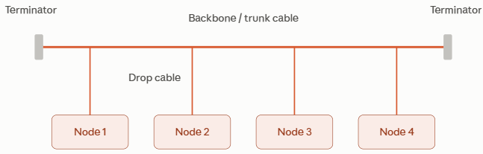
Real-World Application:
- Aircraft In-Flight Entertainment (IFE) / Industrial CAN Bus: Linear bus lines are deployed within physical sensor systems, automotive controllers (CAN Bus in vehicles), or internal in-flight cabin distribution systems where a single lightweight shared line routes sequentially across rows of passenger displays or telemetry sensors.

Task 2: Star topology in Cisco Packet Tracer

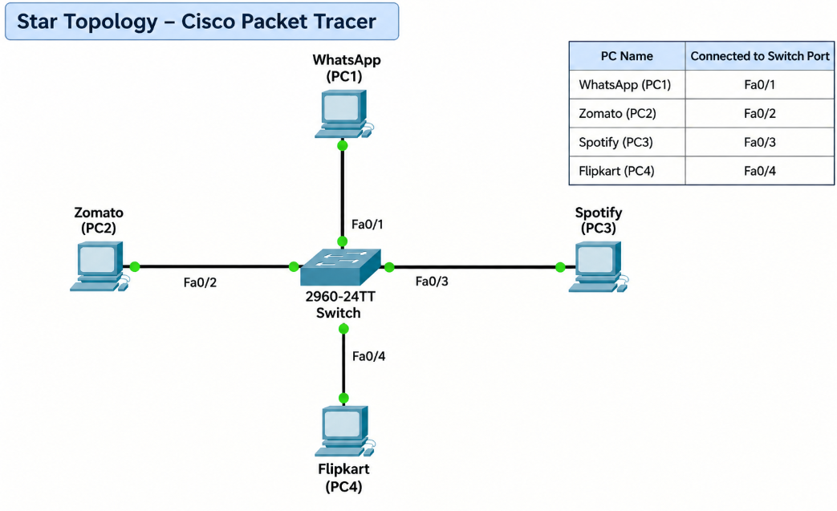

Task 3: Ring Topology Diagram & Data Transmission Flow

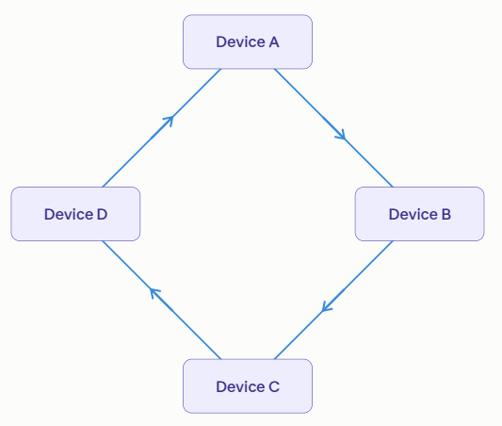
How Data Travels:
- In a ring topology, all devices are connected in a continuous,
closed physical or logical loop where each node is directly
linked only to its two immediate neighbors.
- Data travels sequentially from one device to the next in a
single direction (unidirectional ring) around the loop
using a small electronic control frame known as a token.
- When a node receives a frame, it inspects
the destination MAC/address header: if
the frame is intended for another node, the
device acts as a repeater, regenerating the signal and
passing it downstream until the true destination host
accepts it and returns an acknowledgment.

Task 4: Mesh vs Star Topology Comparison

Topology | Advantages (2 Points) | Disadvantages (2 Points)
Star Topology | 1. Fault Isolation: A cable cut or fault on one node's link only affects that individual device; the rest of the network operates normally.  2. Ease of Expansion: Adding new devices requires only running a single cable to an open switch port without interrupting ongoing communications. | 1. Single Point of Failure: If the central switch or hub crashes, the entire local network goes completely offline.  2. Port Dependency: Expansion is strictly bounded by the number of physical ports available on the central hardware switch.
Mesh Topology | 1. Exceptional Redundancy: Multiple redundant point-to-point links ensure data routes seamlessly around broken cables or failed interfaces without total outages.  2. High Security & Throughput: Dedicated direct links prevent data from traversing intermediary shared hosts, eliminating local node snooping and bottlenecking. | 1. High Implementation Cost: Requires an exponential amount of cabling and multiple NIC interfaces per device ($n\left(n-1\right)/2$ links for full mesh).  2. Installation & Management Complexity: Physically configuring, terminating, and maintaining dozens of point-to-point links is difficult to manage and scale.

